**Report on Tourism Management System**

1. **Introduction**

## 1.1 Project objective

## Travel Management System is a web-based application for travel agencies. The main objective of this project is to create a fast, effective and reliable working platform to develop a [communication system](https://www.codewithc.com/client-server-communication-system-asp-net/) between customers and the agency. In the existing system, the user needs to visit the travel agency office to plan any tour. It involves a lot of manual paper works and the customers need to stay on queue for a long time. To root out such drawbacks of travel agencies, the whole system of management requires to be automated using technology. The proposed web-based project on travel management is an solution to the existing problems regarding cruise management in various travel agencies. The user need to just login into the application and can find the information about the available tours and packages. It also assists in promotion of [tourism](https://www.codewithc.com/online-tourism-management-system-vb-net-project/) by providing information regarding different places. Also the user can enter his feedback about the travel and tourism agency. The system is secure, intuitive and user friendly. Thus, it is beneficial for both travel management agencies and the customers.

**1.2 Features**

Listed below are the key features of Travel Management System:

* **Programming language:**The proposed project has been coded in web languages with database connectivity.
* **Security:**The system is fully password protected. Only authorized users can get access.
* **Flexibility:** The project has been designed in such a way that new features and modules can be added into the system in future as per user requirements.
* **Reliable:** Besides offering dynamically generated tours, various tour packages have also been included. This system also suggests travel plans and best deals based on users preferences.
* **Time Saving:** The customers need not to visit the travel agency office to purchase any tour package. One can access the travel management office from anywhere on the web.
* **Self-documenting:-** All the information about the customers along with date of journey and return, tour destination, package, rooms and various other related things are added to the database automatically by the software itself.
* Feedback and other general features have also been added.

1. **System Design**

**2.1 Input design**

Input design is the link that ties the information system into the world of its users. The input design involves determining what the inputs are, how to validate the data, how to minimize the data entry and how to provide a multi-user facility. Inaccurate input adapt are the most common cause of errors in data processing. Input design is the process of converting user-originated inputs to a computer based format. Input data are collected and organized into groups of similar data. Once identified, the appropriate input media are selected for processing. All the input data are validated in the order and if any data violates any conditions, the user is warned by a message. If the data satisfies all the conditions then it is transferred to the appropriate tables in the database.

A page is designed for entering these details which is user friendly so that an authorized user with even less computer knowledge can enter the data. User enters their username and password for login. New users give their completed personal details, address, email and phone number for registration. Pages are designed to traverse through home, sign in, myaccount, feedback, holiday packages, best deals, about us and contact us, in a very user friendly manner so that the user can access with minimum effort. User can then enter the date of journey and return, they can also select the packages, number of rooms etc and can get the best deals based on users preferences. Also, the users can give their feedback.

**2.2 Output design**

Computer output is the most important and direct source of information to the user. Output design is a very important phase since the output needs to be in an attractive manner. Efficient and intelligible output design improves the system relationship with the user and helps in decision making. Allowing the user to view the sample screen is important because the user is the ultimate judge of the quality of output.

The output module of this system is the user-friendly window. If the entered data while sign in satisfies all the conditions then it is transferred to the appropriate tables in the database else the user is warned by a message. If the username and password is valid then the user can access all pages else the user is warned by a message showing incorrect username/password. The user then gets the complete information about the various tourist places. The user view the best deals after entering the required data about the tour. A page is designed for showing the best deals with discount prices according to user preferences. A separate page is designed for ‘About us’ showing the information about the travel agency. A page for ‘contact us’ displays the contact details.

**2.3 Database design**

Databases are the storehouses of data used in the software systems. The data is stored in tables inside the database. Several tables are created for the manipulation of the data for the system. Two essential settings for a database are

Primary Key- the field that is unique for all the record occurrences.

Foreign Key-the field used to set relation between tables. Normalization is a technique to avoid redundancy in the tables.

Important tables used in the project include:

1. customer

|  |  |  |  |  |  |  |  |
| --- | --- | --- | --- | --- | --- | --- | --- |
| cid | fname | lname | mname | add | email | pno | pwd |
| 10 | raj | Sharma | mohan | borivali | [raj123@gmail.com](mailto:raj123@gmail.com) | 9974218600 | rsm123 |
| 20 | seema | kumar | rakesh | santacruz | seema99@gmail.com | 9422354665 | 8644ss |

1. destination

|  |  |  |  |  |
| --- | --- | --- | --- | --- |
| did | source | destination | depart | return |
| 23 | MU | KS | 27-10-18 | 3-11-18 |
| 45 | DL | BL | 30-10-18 | 7-11-18 |

1. package

|  |  |  |
| --- | --- | --- |
| pid | nor | pack |
| 87 | 2 | Superdelux |
| 90 | 1 | Deluxe |

1. feedback

|  |  |  |  |  |
| --- | --- | --- | --- | --- |
| Fid | What was your first impression when you entered website? | How did you first hear about us? | Is there anything missing on this page? | How likely are you to recommend us to a friend or collegue? |
|  |  |  |  |  |
|  |  |  |  |  |

1. **Codes**

formvalidation.js

function formvalidation()

{

var fname=document.registration.t2;

var lname=document.registration.t3;

var mname=document.registration.t4;

var pw=document.registration.t8;

var uadd=document.registration.t6;

var uemail=document.registration.t5;

var uphone=document.registration.t7;

if(password_validation(pw,7,12))

{

if(allLetter(fname))

{

if(allLetter(lname))

{

if(allLetter(mname))

{

if(alphanumeric(uadd))

{

if(ValidateEmail(uemail))

{

if(allnumeric(uphone))

{

alert("Successfully submitted");

}

}

}

}

}

}

}

}

function password_validation(pw,mx,my)

{

var pw_len=pw.value.length;

if(pw_len==0 || pw_len>my || pw_len<=mx)

{

alert("Password should not be empty/length be between "+mx+ "to" +my);

pw.focus();

return false;

}

return true;

}

function userid_validation(uid,mx,my)

{

var uid_len=uid.value.length;

if(uid_len==0 || uid_len>my || uid_len<=mx)

{

alert("user id should not be empty/length be between "+mx+ "to" +my);

uid.focus();

return false;

}

return true;

}

function allLetter(fname)

{

var letters=/^[A-Za-z]+$/;

if(fname.value.match(letters))

{

return true;

}

else

{

alert("username must have alphabets only");

fname.focus();

return false;

}

}

function allLetter(lname)

{

var letters=/^[A-Za-z]+$/;

if(lname.value.match(letters))

{

return true;

}

else

{

alert("username must have alphabets only");

lname.focus();

return false;

}

}

function allLetter(mname)

{

var letters=/^[A-Za-z]+$/;

if(mname.value.match(letters))

{

return true;

}

else

{

alert("username must have alphabets only");

mname.focus();

return false;

}

}

function alphanumeric(uadd)

{

var letters=/^[0-9a-zA-Z, ]+$/;

if(uadd.value.match(letters))

{

return true;

}

else

{

alert("User address must have alphanumeric characters only");

uadd.focus();

return false;

}

}

function ValidateEmail(uemail)

{

var mailformat = /^\w+([\.-]?\w+)*@\w+([\.-]?\w+)*(\.\w{2,3})+$/;

if(uemail.value.match(mailformat))

{

return true;

}

else

{

alert("You have entered an invalid email address!");

uemail.focus();

return false;

}

}

function allnumeric(uphone)

{

var numbers = /^[0-9]+$/;

if(uphone.value.match(numbers))

{

return true;

}

else

{

alert('phone no must have numeric characters only');

uphone.focus();

return false;

}

}

Formvalidation1.js

function formvalidation()

{

var fname=document.registration.fname;

var pw=document.registration.password;

if(password_validation(pw,7,12))

{

if(allLetter(fname))

{

alert("Successfully submitted");

}

}

}

function password_validation(pw,mx,my)

{

var pw_len=pw.value.length;

if(pw_len==0 || pw_len>my || pw_len<=mx)

{

alert("Password should not be empty/length be between "+mx+ "to" +my);

pw.focus();

return false;

}

return true;

}

function allLetter(fname)

{

var letters=/^[A-Za-z]+$/;

if(fname.value.match(letters))

{

return true;

}

else

{

alert("username must have alphabets only");

fname.focus();

return false;

}

}

home.html

<html>

<head>

<title>Tourism Management System</title>

<style>

ul {

list-style-type: none;

margin: 0;

padding: 0;

overflow: hidden;

background-color: #333;

}

li {

float: left;

}

li a {

display: block;

color: white;

text-align: center;

padding: 14px 16px;

text-decoration: none;

}

li a:hover {

background-color: #111;

}

</style>

</head>

<body>

<center><font face="Brush Script MT" size=8>Travel Agency</font></center>

<p align=right><a href=sign.html>Sign in |</a><a href=account.html>My Account |</a>

<body bgcolor="#FEF9E7 ">

<ul>

<li><a class="active" href="home.php">Home</a></li>

<li><a href="package.html">Holiday Packages</a></li>

<li><a href="best.html">Best Deals</a></li>

<li><a href="about.html">About Us</a></li>

<li><a href="contact.html">Contact Us</a></li>

</ul>

<form action="home.php" method=get>

<!--<img src="C:\xampp\htdocs\project\13.jpg" alt=home width=1400 height=500>-->

</body>

</html>

home.php

<html>

<head>

<title>Tourism Management System</title>

<style>

ul {

list-style-type: none;

margin: 0;

padding: 0;

overflow: hidden;

background-color: #333;

}

li {

float: left;

}

li a {

display: block;

color: white;

text-align: center;

padding: 14px 16px;

text-decoration: none;

}

li a:hover {

background-color: #111;

}

</style>

</head>

<body>

<center><font face="Brush Script MT" size=8>Travel Agency</font></center>

<p align=right><a href=sign.html>Sign in |</a><a href=account.html>My Account |</a>

<body bgcolor="#FEF9E7 ">

<ul>

<li><a class="active" href="home.php">Home</a></li>

<li><a href="package.html">Holiday Packages</a></li>

<li><a href="best.html">Best Deals</a></li>

<li><a href="about.html">About Us</a></li>

<li><a href="contact.html">Contact Us</a></li>

</ul>

<?php

echo "<img src='3.jpg' alt='home' width=1400 height=500 />";

?>

<!--<img src="C:\xampp\htdocs\project\13.jpg" alt=home width=1400 height=500>-->

</body>

</html>

Account.html

<html>

<head>

<title>Tourism Management System</title>

<script src="formvalidation1.js"></script>

<style>

ul {

list-style-type: none;

margin: 0;

padding: 0;

overflow: hidden;

background-color: #333;

}

li {

float: left;

}

li a {

display: block;

color: white;

text-align: center;

padding: 14px 16px;

text-decoration: none;

}

li a:hover {

background-color: #111;

}

</style>

</head>

<body onload="document.registration.userid.focus();">

<center><font face="Brush Script MT" size=8>Travel Agency</font></center>

<p align=right><a href="sign.html">Sign in |</a><a href="account.html">My Account |</a>

<body bgcolor="#FEF9E7 ">

<ul>

<li><a class="active" href="home.html">Home</a></li>

<li><a href="package.html">Holiday Packages</a></li>

<li><a href="best.html">Best Deals</a></li>

<li><a href="about.html">About Us</a></li>

<li><a href="contact.html">Contact Us</a></li>

</ul>

<center><h1>My Account</h1></center>

<form name="registration" action="account.php" method="post">

<center>

<table>

<tr>

<td>First name:</td>

<td><input type="text" name="t2"/></td>

</tr>

<tr>

<td>Password:</td>

<td><input type="password" name="t8"/></td>

</tr>

</table>

<br><br>

<input type="submit" name="submit" value="submit">

</center><br><br>

<p align=right><a href="display.html">Account details</a></p>

<p align=right><a href="deletion.html">Do you want to delete your account?</a></p>

<p align=right><a href="update.html">Do you want to update your account?</a></p>

<p align=right><a href="feedback.html">Feedback</a></p>

</form>

</body>

</html>

Account.php

</body>

</html>

<?php

mysql_connect("localhost","root","") or die(mysql_error());

$db="tourism";

mysql_select_db($db) or die(mysql_error());

$t2=$_POST['t2'];

$t8=$_POST['t8'];

$q="select fname,pwd from customer where fname='$t2' and pwd='$t8' ";

$no_of_rows=mysql_num_rows(mysql_query($q));

#echo $no_of_rows;

if($no_of_rows==0){

echo '<script language= "javascript">';

echo 'alert("Incorrect Username or Password")';

echo '</script>';

echo '<a href="account.html">Enter correct username or password</a>';

}

else{

echo '<script language= "javascript">';

echo 'alert("Successfully Logged in!")';

echo '</script>';

echo '<a href="package.html">Select Package</a>';

}

?>

</body>

</html>

insertion.html

<html>

<head>

<script src="formvalidation.js"></script>

</head>

<body>

<?php

$t1=(mt_rand(1,100));

$t2=$_POST["t2"];

$t3=$_POST["t3"];

$t4=$_POST["t4"];

$t5=$_POST["t5"];

$t6=$_POST["t6"];

$t7=$_POST["t7"];

$t8=$_POST["t8"];

mysql_connect("localhost", "root","") or die (mysql_error());

$dbase_name="tourism";

mysql_select_db($dbase_name) or die (mysql_error());

$query="insert into customer values('$t1','$t2','$t3','$t4','$t5','$t6','$t7','$t8')";

mysql_query($query) or die (mysql_error());

echo '<script language= "javascript">';

echo 'alert("Account created successfully")';

echo '</script>';

echo '<script>window.location="account.html"</script>';

mysql_close();

?>

</body>

</html>

1. **Screenshots**

1.

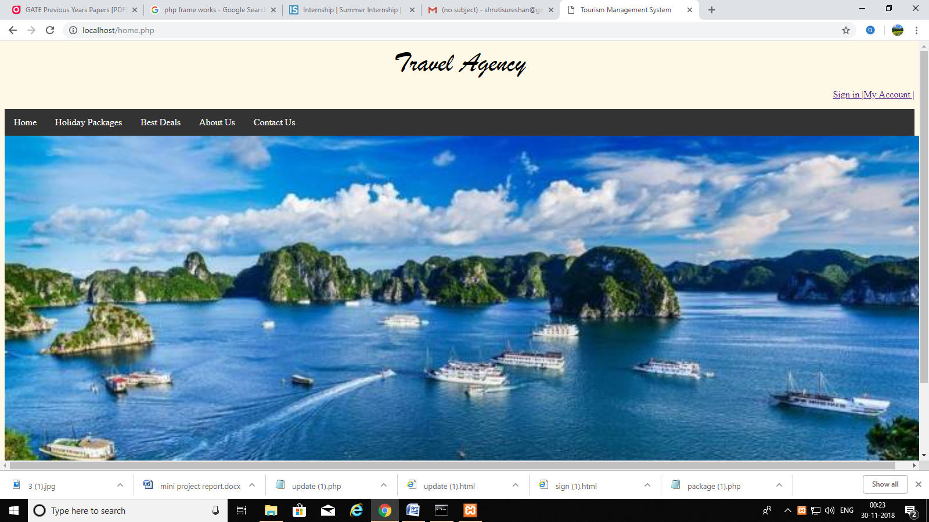

2.

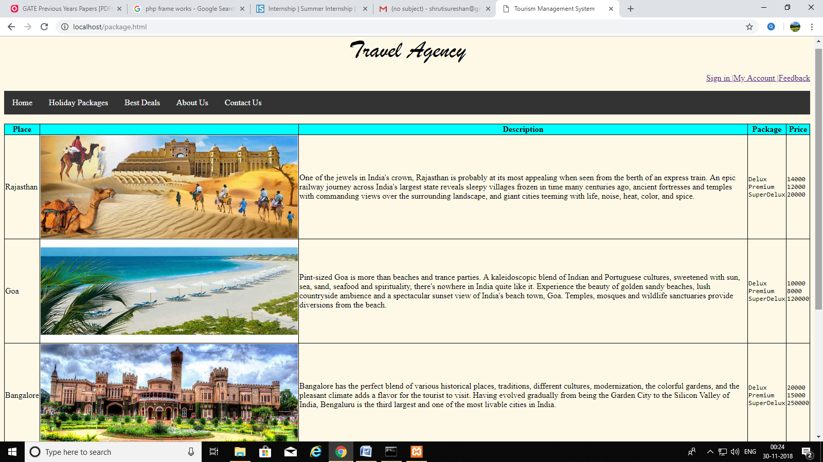

3.

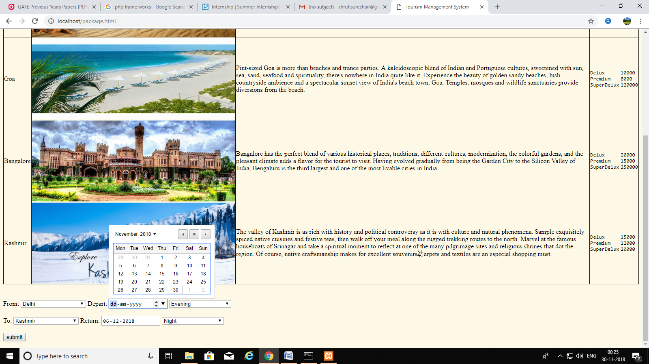

4.

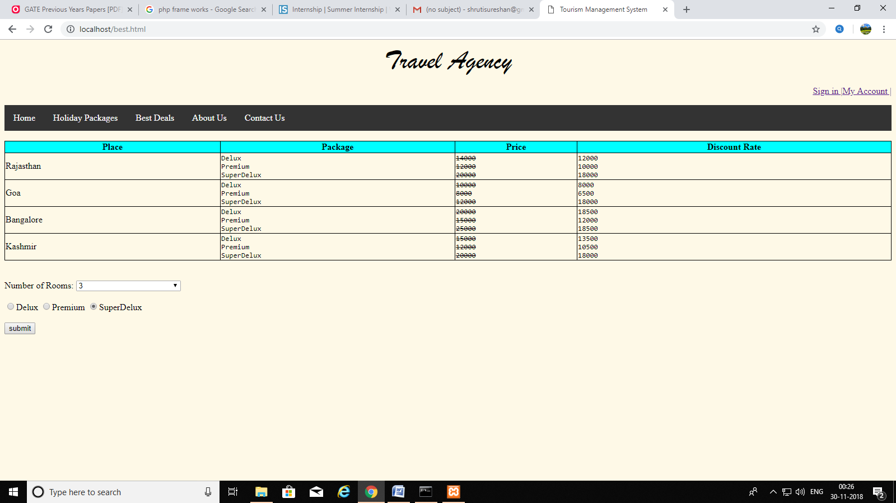

5.

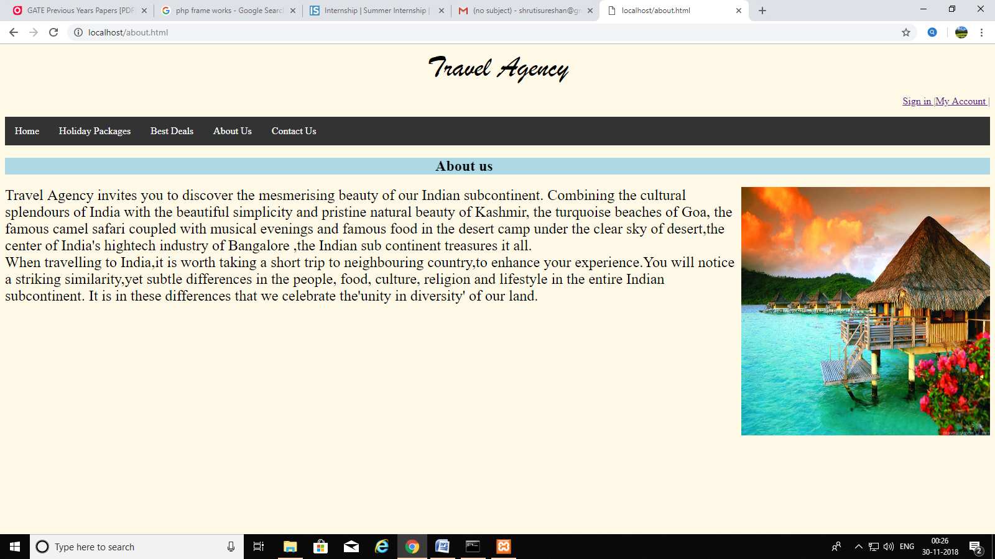

6.

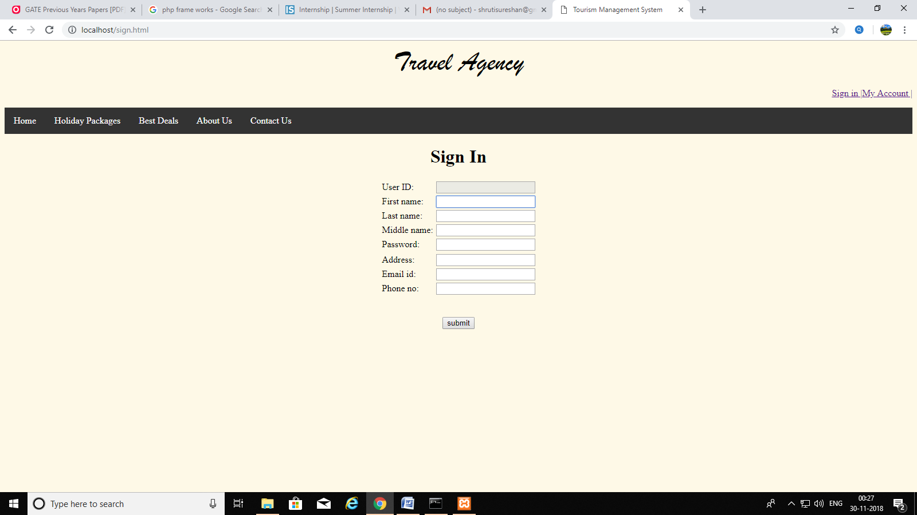

7.

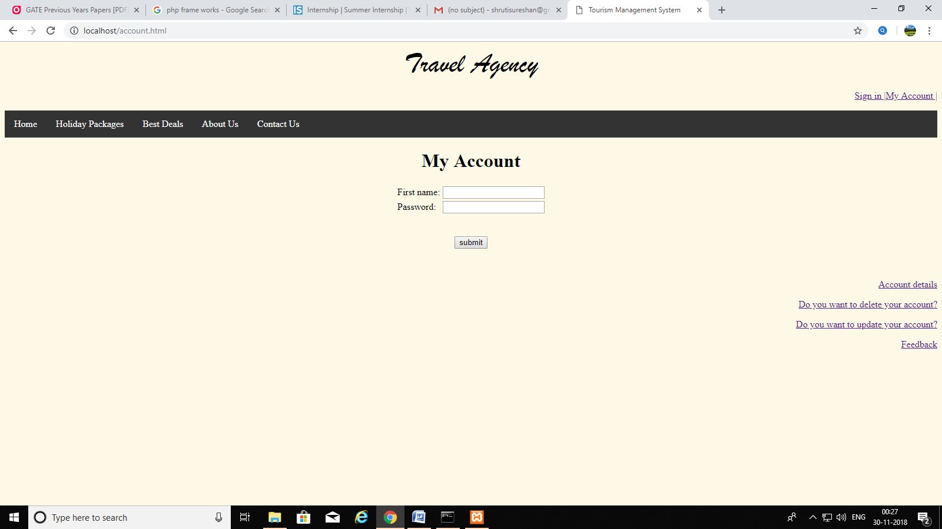

1. **Conclusion**

“Tourism Management System” simplifies the management process in travelling. Fast processing and immediate results with high security. Minimizing human effort and cost efficient databases. Navigation through the site is easy.

1. **Future scope**

Any tourist agency can make use of it for saving customer details in database. Tourism group can use it for managing their location, hotel, vehicles details. This application can easily implemented under various situations. We can add new features as and when we require. Reusability of this application is also possible.